Descriptive analysis of medical data

Contents
1. Descriptive analysis of qualitative data 2
2. Descriptive analysis of quantitative data 4

1. Descriptive analysis of qualitative data
Table 1. Frequency table for hepatitis type
Hepatitis type (Type A / Type B / Type C) | Counts | % of Total | Cumulative %
Type A | 99 | 66.0% | 66.0%
Type B | 26 | 17.3% | 83.3%
Type C | 25 | 16.7% | 100.0%

Table 2. Frequency table for symptoms at discharge
Symptoms at discharge (Present/Absent) | Counts | % of Total | Cumulative %
Present | 52 | 34.7% | 34.7%
Absent | 98 | 65.3% | 100.0%

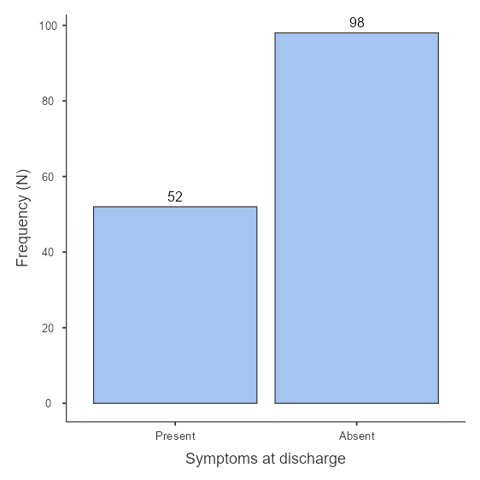
Figure 1. Distribution of patients by symptoms at discharge

Example of interpretation: In the studied sample, more patients were discharged without symptoms than with symptoms.
Table 3. Relationship between obesity and smoking
 | Obesity (Normal weight / Overweight / Obese)
Smoking (Yes/No) | Normal weight | Overweight | Obese | Total
Yes | 20 | 13 | 3 | 36
No | 50 | 36 | 28 | 114
Total | 70 | 49 | 31 | 150

Example of interpretation: Of the patients who are overweight, …. % are smokers.

Plots
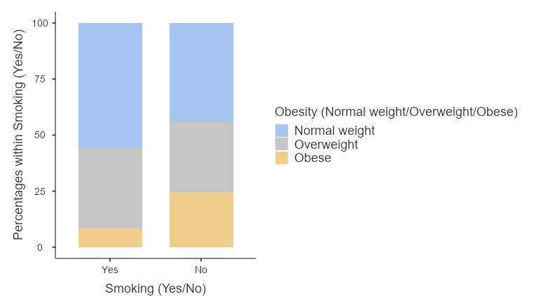
Figure 2. Relationship between smoking and obesity

Example of interpretation: Among smokers, the highest frequency was in the …… category.

2. Descriptive analysis of quantitative data
Table 4. Calculation of the statistical indicators
 | Age (years) | Weight (kg) | Cholesterol (mg/dL)
N | 136 | 136 | 136
Mean | 56.6 | 79.7 | 206
Std. error mean | 1.67 | 1.11 | 3.45
Median | 56.5 | 80.0 | 205
Mode | 64.0 | 80.0ᵃ | 176ᵃ
Standard deviation | 19.5 | 13.0 | 40.2
Variance | 379 | 169 | 1617
Range | 80 | 57 | 209
Minimum | 18 | 52 | 118
Maximum | 98 | 109 | 327
Skewness | 0.132 | 0.0822 | 0.327
Std. error skewness | 0.208 | 0.208 | 0.208
Kurtosis | -0.890 | -0.440 | -0.159
Std. error kurtosis | 0.413 | 0.413 | 0.413
25th percentile | 40.8 | 71.0 | 176
50th percentile | 56.5 | 80.0 | 205
75th percentile | 70.3 | 87.3 | 232
ᵃ More than one mode exists, only the first is reported
Table 5. Interpretation of the statistical indicators
Indicators | Cholesterol (mg/dL)
Central tendency
Mean | The average cholesterol level in the sample was ……
Median
Mode | Several values occur equally often (multimodal).
Shape
Skewness
Kurtosis
Position
Quartile 1 (Q1)

Histogram
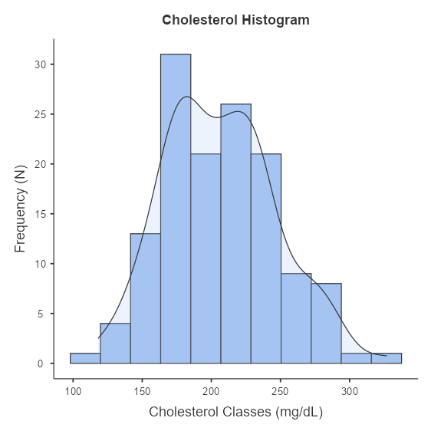

Figure 3. Cholesterol histogram
Example of interpretation: According to the graph, cholesterol …….

Box Plot
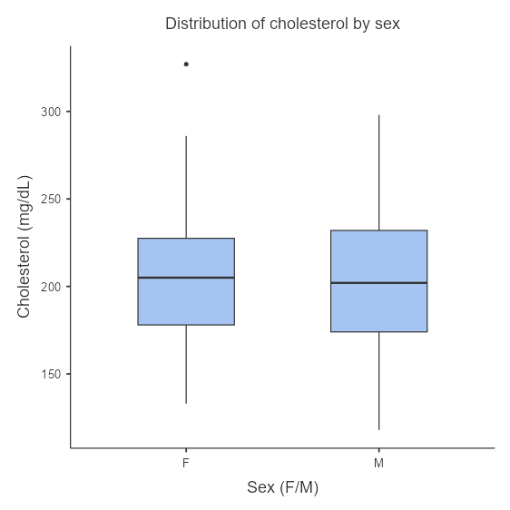
Figure 4. Distribution of cholesterol by sex

Example of interpretation: Cholesterol values were ……..
Scatter Plot
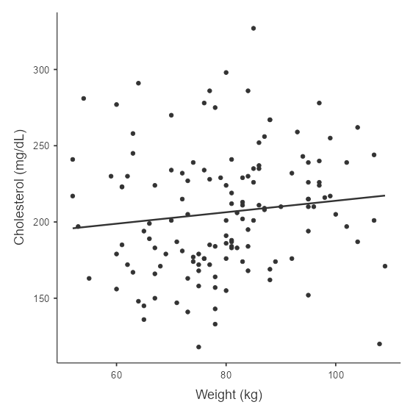
Figure 5. Relationship between weight and cholesterol

