TO DO: Practical activities. Searching in bibliographic databases

Aims and benefits of this practical activity
- Performing a scenario based search using the PICO method.
- Creating a search strategy to identify a manageable number of articles on a certain research topic.
- Using Clinical Queries and search restrictions by certain criteria offered in PubMed (e.g. by article type, year of publication, etc.).
- Acquiring the skills for writing references in the Vancouver style standard.
- Creating a bibliographic record file with a table of contents, to easily retrieve items of interest by title.
- Aquiring bibliographic documentation skills for research and current practice.

Clinical Queries allows the search for clinical studies according to their type: therapy, diagnostic, prognostic (risk factors).

Searching for Therapy information
Scenario: You are interested in the usefulness of betablockers in heart failure.
Clinical Question: In Heart Failure, Is Bisoprolol more effective than Carvedilol for the reduction of patient Mortality?

We will use the PICO technique, as presented below:
P - patient/problem to be solved (usually the name of the disease) | Heart failure
I - intervention of interest (e.g. a drug/medication) | Bisoprolol
C - comparison (e.g. another drug/medication) | Carvedilol
O - outcome of interest /objective (e.g. reduction of mortality) | Mortality

We will perform the search using the resources available at the following addresses:
- https://pubmedhh.nlm.nih.gov/nlmd/pico/piconew.php:
We can observe a number of 149 articles resulting from the above search.
From the results page, we will have access to the Abstract and the Full Text, respectively.
- https://www.ncbi.nlm.nih.gov/pubmed/clinical:
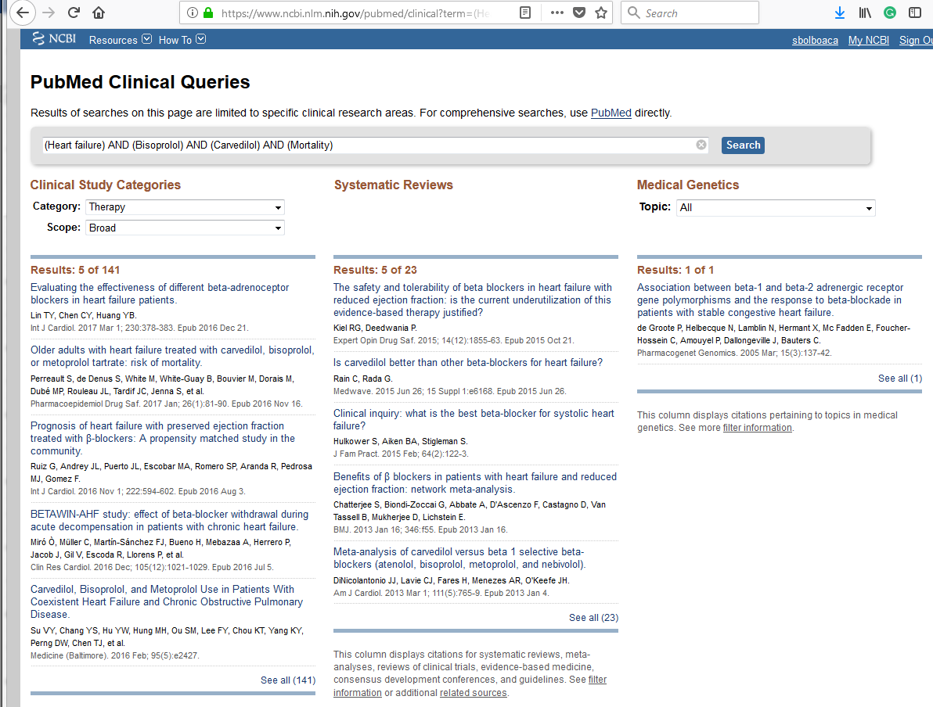

In this case we obtain 141 search results.
On the results page we are presented with two categories of results:
- All results: 141 articles.
- Systematic Reviews: 23.
Scenario: You are interested to find out which of two possible treatments for type 2 diabetes mellitus (insulin or hypoglycemic agents) does not affect the body weight of treated patients.
- Write the PICO components for this scenario in the table below:
P
I
C
O
- Perform the above search, using the resources available at https://pubmedhh.nlm.nih.gov/nlmd/pico/piconew.php. Write the number of articles this resource gives you access to:

- Perform the above search on https://www.ncbi.nlm.nih.gov/pubmed/clinical, then answer the following questions:
- Write the number of items identified by the search when using the Therapy category and a Broad scope:
- Write the number of items identified by the search when using the Therapy category and a Narrow scope:
- Further refine your search in the Therapy category with Narrow scope by applying the following criteria:
Languages = English
Species = Humans
Publication dates = last 10 years
Text availability = Free full text
Write the number of items identified after applying the criteria in point C:

- Write the Vancouver-style reference for the most recent item among those identified in the previous point:

- Which of the two types of resources (original researches or systematic reviews) is preferable, in your opinion? Justify your answer.

Instructions:
- To select the most relevant search results, display all results by accessing the link See all.

Searching for Diagnostic information
Scenario: You wish to find the better of two imaging methods to diagnose colorectal cancer (Colorectal Neoplasms).
Clinical question: Is Computed Tomography more sensitive (Sensitivity) compared to Magnetic Resonance Imaging in the diagnosis of Colorectal Neoplasms?
- Write the PICO components for this scenario in the table below:
P
I
C
O
- Perform the above search, using the resources available at https://pubmedhh.nlm.nih.gov/nlmd/pico/piconew.php. Write the number of articles this resource gives you access to:

- Perform the above search on https://www.ncbi.nlm.nih.gov/pubmed/clinical, then answer the following questions:
- Write the number of items identified by the search when using the Diagnosis category and a Narrow scope:

- How many of these results are systematic reviews?

- Write the Vancouver-style reference for the most recent item among those identified in the previous point:

- Do you think that the article entitled Comparison between 3-T magnetic resonance imaging and multi-detector row computed tomography for the preoperative evaluation of rectal cancer available at https://www.ncbi.nlm.nih.gov/pubmed/18043346 could answer the question of interest? After reading the summary of this article, answer the questions in the table below:
What was the aim of the study?
Describe the studied sample:
What has been evaluated?
How many evaluators were involved?
What was the standard diagnostic method used as reference in this study?
≤T2 3T-MRI
Se (Sensitivity)
Sp (Specificity)
Ac (Accuracy)
≤T2 MDCT
Se (Sensitivity)
Sp (Specificity)
Ac (Accuracy)
Which of the two methods has higher accuracy in staging colorectal cancer?

Searching for information on Prognosis / Ethiology and risk factors
Scenario: A series of dental implants has been applied to one of your friends, after initial bone augmentation procedures of the alveolar ridge. You notice that your friend continues to smoke regularly, and wonder whether smoking could affect the bony integration of these implants, leading to their mobilization and failure.
- Write the PICO components for this scenario in the table below:
P
I
C | Optional component for risk factor assessment (understood as lack of exposure)
O

- Perform the above search, using the resources available at https://pubmedhh.nlm.nih.gov/nlmd/pico/piconew.php. Write the number of articles this resource gives you access to:

- Perform the above search on https://www.ncbi.nlm.nih.gov/pubmed/clinical, then answer the following questions:
- Write the number of items identified by the search when using the Diagnosis category and a Narrow scope:

- Write the Vancouver-style reference for the article entitled Smoking interferes with the prognosis of dental implant treatment: a systematic review and meta-analysis (https://www.ncbi.nlm.nih.gov/pubmed/17509093):

- Find the full-text of the above article and write the required answers in the table below:
Note how many studies have been evaluated in this meta-analysis:
Write the article's conclusion:
Write the 95% confidence interval of the odds ratio (OR) of smokers vs. non-smokers for post-implantation complications, when also accompanied by procedures for bone augmentation of the alveolar ridge:

Searching for information in books and treatises
Utility: to answer general medical questions
Disadvantages: Information is potentially obsolete, even if the books or treatises have been published recently.
To search for existing books and treatises in the UMF Cluj library you can access the library search engine at: http://www.liberty.umfcluj.ro

Scenario: You want to conduct your graduation thesis at the Department of Microbiology. To get an overview on several aspects in this area in order to discuss them with your future thesis coordinator, you've been looking for a comprehensive microbiology book to update your knowledge in that domain. The coordinator told you that an appropriate source would be a treaty whose title begins with the word Burton (Burton's Microbiology and something else).
Search Technique: Access the UMF Cluj library search engine.
Fill in the words you know, using the dedicated search box. To the right of the search engine you can refine your search by selecting the search type (basic search, advanced search, authors, corporate authors, lists, series, topics, titles) to find out if this book exists in the University's library.

Write the Vancouver style reference for the identified book:

The bibliographic record:
Utility: Easy access to information you've found to be of interest in articles or books
A bibliographic record should include at least the following information:
- the topic of documentation (in the form of keywords, e.g. the search strategy used)
- the reference: author's name(s), title of the paper, journal name, publication year, volume number, issue number
- the extreme pages of the article
Requirements:
You want to make a bibliographic documentation in order to identify possible diagnostic methods for online gaming disorders (Internet gaming disorders).
Browse to https://www.ncbi.nlm.nih.gov/pubmed/clinical and create a bibliographic record for each article published in 2017 on the above topic, using the model below:

Write the reference of the article:
Copy the link to the article:
Study aim:
Characteristics of the studied sample:
The way participants were motivated to participate:
Where the participants were selected from:
Name of the evaluated diagnostic method:
Conclusion of the study:

Conclusions
- Bibliographic documentation is an essential step both in the preparation and planning of research and in the updating of your medical skills, as medical knowledge continuously develops.
- The quoting of consulted sources is mandatory, and in the field of medicine, it must observe the Vancouver referencing style.

To remember
- The bibliographic study represents the study of specialized literature.
- The bibliographic record contains the identification data of scientific articles, papers, specialty books and treatises.
- The PICO search technique is used to create specific search strategies.

